Pediatric Dosage Calculation Review
Nursing 101

1. Order: Amoxicillin 40 mg/kg/day, po every 8 hours.
Wt: 34 pounds
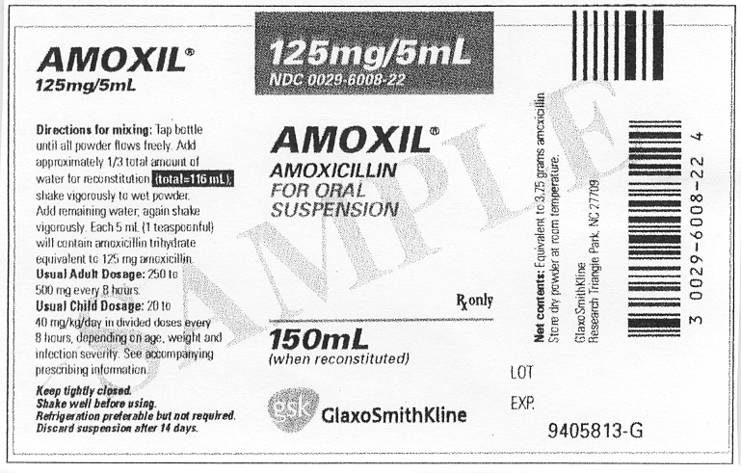

Give: _________

2. Order: Kantrex 10mg/kg/day I.M. every 12 hours.
Wt: 33 pounds
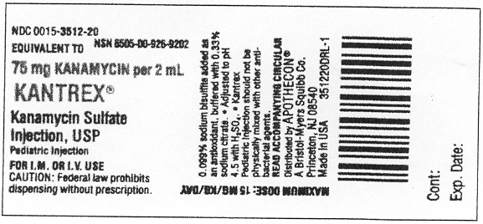

Give: __________________

3. Order: Geopen 100mg/kg/day, p.o. QID.
Wt: 33 pounds
Supply: Geopen 1gm/4mls

Give: ___ _________________
4. Order: Keflex 25mg/kg/day in four divided doses.
Wt: 44 pounds
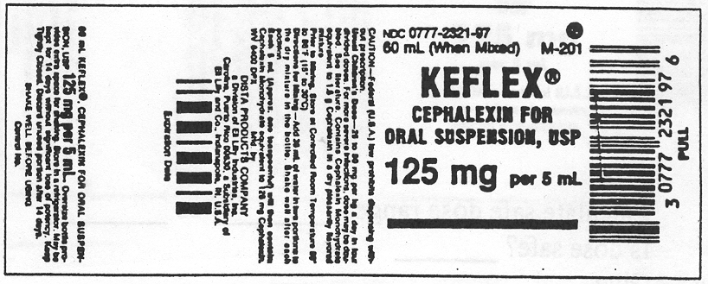

Give: ____ ________________

5. Order: Tobramycin 2 mg/kg IV every 8 hours.
Wt: 20 pounds
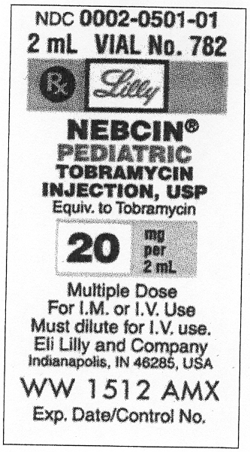
Give: ____________________

6. Order: Give Augmentin 250mg p.o. q 12 hours for 10 days.
Wt: 45 pounds
Recommended dose: 25 mg/kg/day in divided doses every 12 hours.
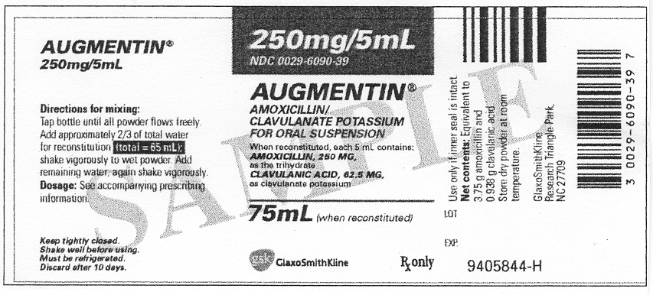

Calculate safe dose: _ _____________

Is ordered dose safe? ___

Give: ____________________

7. Order: Omnipen drops 250 mg p.o. q 6 hours for child with a GI tract infection.
Wt: 22 pounds
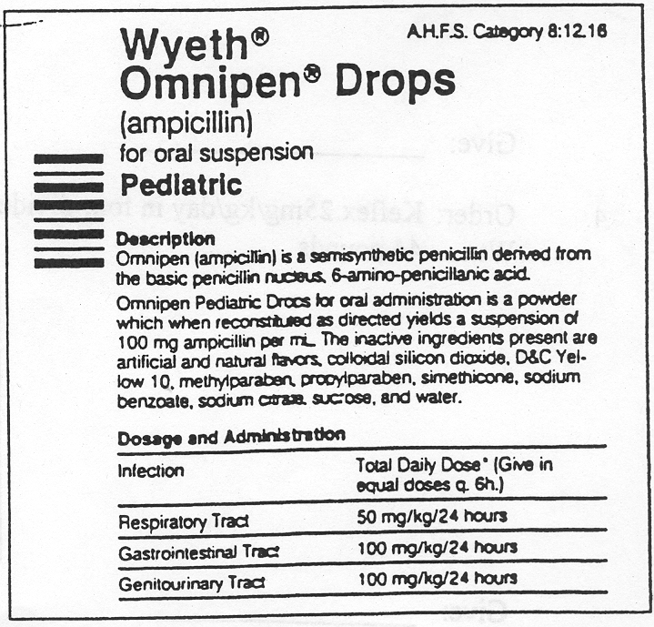

Calculate safe dose:____ _______

Is ordered dose safe? ___ _______

Give: ______________________

8. Give: Polymox 150 mg p.o. q 8 hours
Wt: 33 pounds
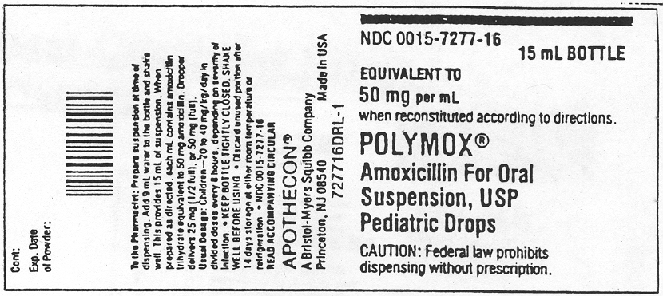

Calculate safe dose range: ________ to ____

Is dose safe? __________

Give: ____ ________________

9. Order: Biaxin 175mg p.o. q 12 hours
Wt: 51 pounds
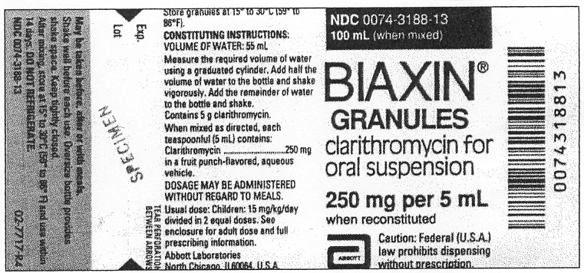

Calculate safe dose: ________________

Is ordered dose safe? _______________

Give ____________________________

10. Order: Ceclor 100 mg p.o. TID
Wt: 33 pounds
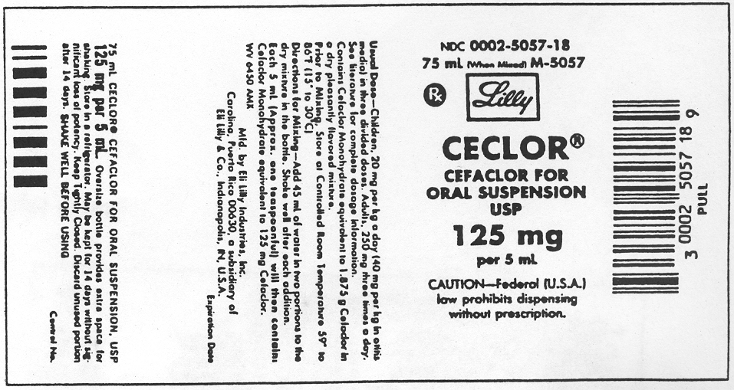

Calculate safe dose range: ________ to _________

Is dose safe? __________

Give: ____________________

Show amount on syringe 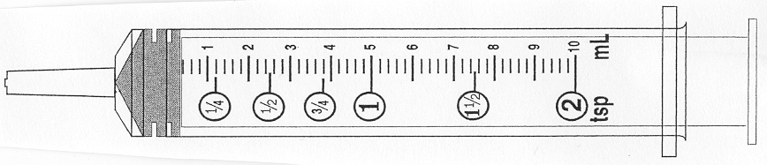

101 pediatric dosage calculation review.doc 3/2010

